Research Activities Fund Report (SGS14R)

Important Notes:

- This Research Activities Fund Report should be completed and submitted to the Chow Yei Ching School of Graduate Studies (SGS) within two months after completing your research activities.

- Reimbursement of the Research Activities Fund will be made directly to the student’s bank account as listed in the Scholarship and Financial Aid function under AIMS.

Section A To be completed by the awardee (* please delete as appropriate)
1. | Personal Particulars
 | Name: |  |  |  | Student No.: |  |  |  |  |  | School/Department:
 | Programme: |  |  | Mode of Study: |  |  |  |  | Source of Funding:
 | Email: |  |  |  |  |  |  | Phone No.:
Are you a Hong Kong PhD Fellowship (HKPF) recipient? No Yes
(If yes, please state the expenses incurred from the cost of one return passage below to claim for reimbursement through the “Conference and Research Related Travel Allowance of Hong Kong PhD Fellowship Scheme”:
Currency: ; Amount: )
 | Are you a Presidential PhD Scholarship (PPS) recipient? No Yes

- Claim for Reimbursement of Research Activities Fund

Actual leave period: |  | From: to:
Location(s) (names of cities and countries) where the research activities were undertaken:

Funds claimed: HK$
 | Basic Scheme
 | Research Activity Fund for PPS Recipients
 | Enhanced Scheme (Only opt for once and the choice made is irreversible)

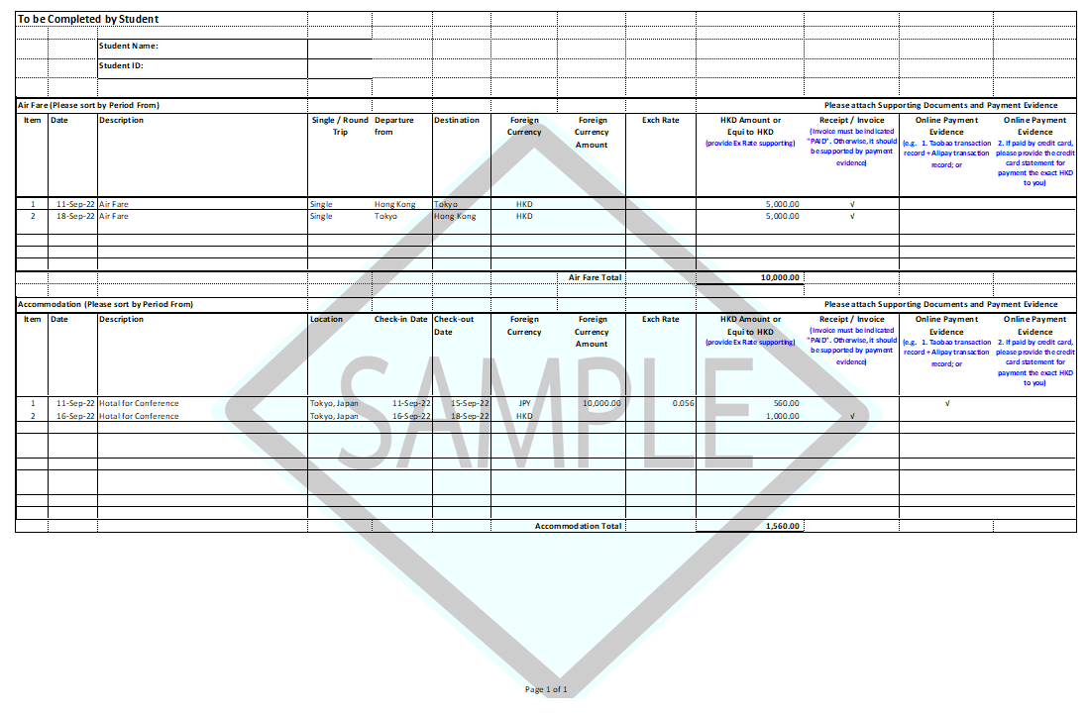
To be Completed by Student
 |  | Student Name:
 |  | Student ID:
Air Fare (Please sort by Period From) |  |  |  |  |  |  |  |  |  | Please attach Supporting Documents and Payment Evidence
Item | Date | Description | Single / Round Trip | Departure from |  | Destination |  | Foreign Currency |  |  | Foreign Currency Amount |  | Exch Rate |  | HKD Amount or  Equi to HKD  (provide Ex Rate supporting) |  | Receipt / Invoice  (Invoice must be indicated "PAID". Otherwise, it should be supported by payment evidence) | Online Payment Evidence  (e.g. 1. Taobao transaction record + Alipay transaction record; or | Online Payment Evidence  2. If paid by credit card, please provide the credit card statement for payment the exact HKD to you)
1
2
 |  |  |  |  |  |  |  |  |  |  | Air Fare Total

Accommodation (Please sort by Period From) |  |  |  |  |  |  | Please attach Supporting Documents and Payment Evidence
Item | Date | Description | Location | Check-in Date | Check-out Date | Foreign Currency |  | Foreign Currency Amount | Exch Rate | HKD Amount or  Equi to HKD  (provide Ex Rate supporting) | Receipt / Invoice  (Invoice must be indicated "PAID". Otherwise, it should be supported by payment evidence) |  | Online Payment Evidence  (e.g. 1. Taobao transaction record + Alipay transaction record; or | Online Payment Evidence  2. If paid by credit card, please provide the credit card statement for payment the exact HKD to you)
1
2
 |  |  |  |  |  | Accommodation Total

- Report on Research Activities

Please provide (a) a brief summary of your research activities and outcomes; and (b) a brief assessment of the value and usefulness of the activities to your research (not less than 200 words) (use separate sheets if necessary):

- List of Supporting Document(s) Required

Please attach the following document(s) to facilitate our processing. Applications with incomplete supporting document(s)
will not be processed. Document(s) submitted are not returnable:
A copy of approval letter on research activities fund.
Original boarding passes.
Original receipts for attending the approved research-related activities, indicating your actual leave period.
- One return passage; and
- Hotel/accommodation for the entire study leave period.
Payment evidence for the following items, along with the bank statement or online transaction record.
  - One return passage; and
  - Hotel/accommodation for the entire study leave period.
Travel records (出入境紀錄證明) issued by the National Immigration Administration (國家移民管理局), if applicable.

Signature |  | Date

Please forward the form and the documents to the Supervisor for recommendation and submission to SGS via your School/Department.

Section B Recommendation of the Supervisor (*please delete as appropriate)

I acceptance of the student’s report on the research-related activities.
Other comments, if any:
Name of Supervisor |  | Signature |  | Date

Please submit this form and the documents to the School/Department.

Section C Endorsement by the School Dean/Department Head (*please delete as appropriate)

I the supervisor’s recommendation stated above.

Other comments, if any:

Signature of School Dean/Department Head |  | Date

Please submit this form and the documents to SGS for processing via the School/Department.

For internal use only
To: FO

The student has fulfilled the requirements for claiming the Research Activities Fund. Please check the receipts attached and arrange for reimbursement through:
Checked by
 | AA | AO
Name
Ext.
Date

Provider | SFAID(s) | Appr. Amt (HK$)
SGS | 669 (UGC) 766 (non-UGC)
Col/Sch/Dept | 858 (non-UGC)
Supervisor | 856 (UGC-related) 857 (External)
HKPFS | #610 (Travel Allowance)
PPS | 1436 (Research Activity Fund: HK$8,000 per month, maximum 12 months)
CPRA | 766 (non-UGC)
Financial Support to PhD Students Working in VHRUs or Top 3 Universities in a Country or National Laboratories | 1543 (Research Activity Fund: HK$5,000 per month,  maximum 12 months) (UGC).  1544 (Research Activity Fund: HK$5,000 per month,  maximum 12 months) (non-UGC)  1545 (Transportation allowance of HK$15,000 at maximum with direct round trip economy flight/ground transportation (e.g. train, coach) on a reimbursement basis) (UGC)  1546 (Transportation allowance of HK$15,000 at maximum with direct round trip economy flight/ground transportation (e.g. train, coach) on a reimbursement basis) (non-UGC)
# For reimbursement of the cost of one return passage

N:\SGS Forms\SGS14R_Research Activities Fund Report.doc
Nov 2025

Changes for bank account can be done directly in AIMS.
Duration in months x HK$5,000 per month, up to a maximum amount of HK$30,000. If the leave period is not on a full month basis, funding will be provided on a pro-rata basis.
HK$8,000 per month, maximum 12 months. If the leave period is not on a full month basis, funding will be calculated on a pro-rata basis.
HK$5,000 per month, maximum 12 months. If the leave period is not on a full month basis, funding will be calculated on a pro-rata basis. Transportation allowance of HK$15,000 at maximum with direct round trip economy flight/ground transportation (e.g. train, coach) on a reimbursement basis.

