Conference Report (SGS13R)

Important Notes:

- Please ensure that all regulations are strictly followed and that all supporting documents are provided in accordance with the approved content of the Conference Grant application (SGS13). Reimbursement will be unavailable for any modifications made after submission or without essential documentation.

- Reimbursement for conference expenses requires a complete conference report with all Section A.6 documents submitted to the Chow Yei Ching School of Graduate Studies (SGS) within two months of the conference end date. Reimbursement will be unavailable for late or incomplete reports.

- Payment will be made directly to the student’s bank account as listed in the Scholarship and Financial Aid under AIMS.

Section A To be completed by the Awardee (* Please delete as appropriate)
1. |  | Personal Particulars
 |  |  | Name: |  |  | Student No.: |  |  |  |  |  | School/Department:
 |  |  | Programme: |  |  | Mode of Study: |  |  |  |  | Source of Funding:
 |  |  | Email: |  |  |  |  |  |  | Phone No.:
 |  |  | Are you a Hong Kong PhD Fellowship (HKPFS) recipient? Yes No
 |  |  | Are you a CityUHK Presidential Research Award (CPRA) Scheme recipient? Yes No

2. | Reimbursement of Expenses Incurred
 | Item |  |  | Expenses Incurred |  | For FO Use
 |  |  |  | Currency | Amount | SGS’s  Conf. grant | Travel allowance@
 | a. | Cost of one return passage
 | b. | Conference registration fee
 | c. | Subsistence allowance  ( night(s), for the period of  - ) | SGS’s Conf. grant  ($300/night,  up to $1,000)
 | c. | Subsistence allowance  ( night(s), for the period of  - ) | Travel Allowance for HKPFS  ($1,000/night)
 | Total amount:

3. | Conference Details
 | Date of Conference: From |  |  | to
 | Title of Conference:
 | Title of the paper:

4. | Seminar Presentation
 | According to the condition for the award of the grant, I have delivered a seminar in the School/Department, with details as follows:
 | Date of Presentation:
 | Topic:

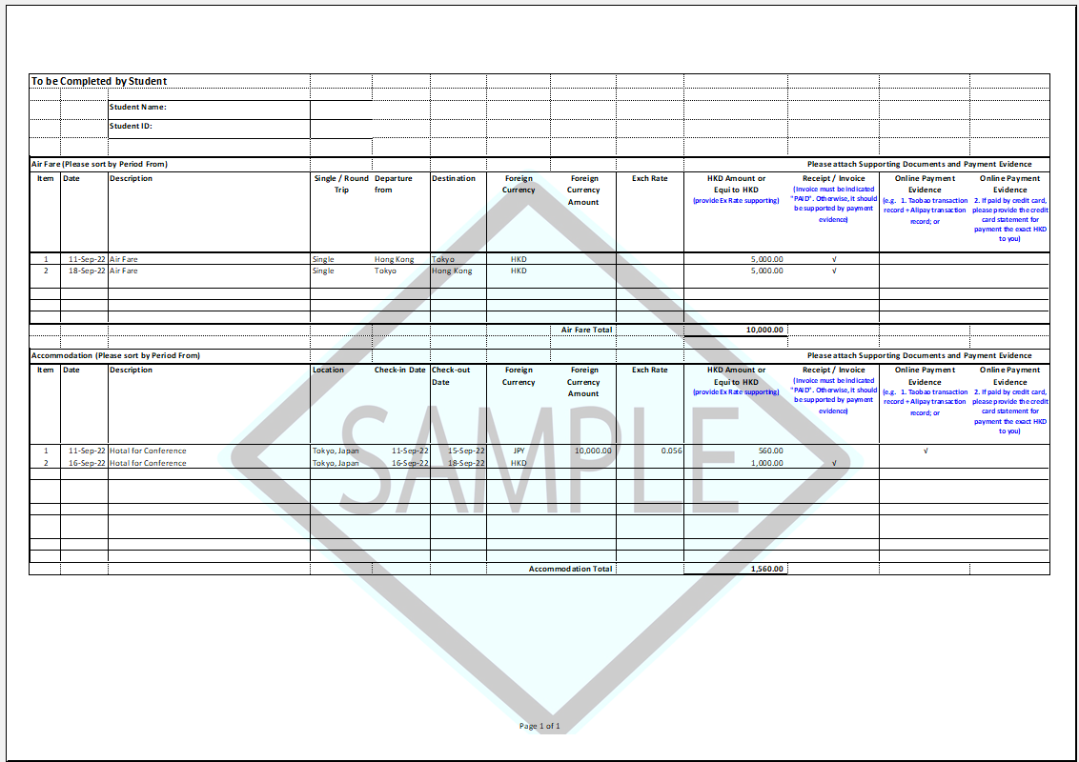

To be Completed by Student
 |  | Student Name:
 |  | Student ID:
Air Fare (Please sort by Period From) |  |  |  |  |  |  | Please attach Supporting Documents and Payment Evidence
Item | Date | Description | Single / Round Trip | Departure from | Destination | Foreign Currency |  | Foreign Currency Amount | Exch Rate | HKD Amount or  Equi to HKD  (provide Ex Rate supporting) | Receipt / Invoice  (Invoice must be indicated "PAID". Otherwise, it should be supported by payment evidence) | Online Payment Evidence  (e.g. 1. Taobao transaction record + Alipay transaction record; or | Online Payment Evidence  2. If paid by credit card, please provide the credit card statement for payment the exact HKD to you)
1
2
 |  |  |  |  |  |  |  | Air Fare Total

 | Accommodation (Please sort by Period From) |  |  |  |  |  |  |  |  |  |  |  |  | Please attach Supporting Documents and Payment Evidence
 | Item |  | Date |  | Description |  | Location |  | Check-in Date |  | Check-out Date |  | Foreign Currency |  |  | Foreign Currency Amount |  | Exch Rate |  | HKD Amount or  Equi to HKD  (provide Ex Rate supporting) | Receipt / Invoice  (Invoice must be indicated "PAID". Otherwise, it should be supported by payment evidence) |  | Online Payment Evidence  (e.g. 1. Taobao transaction record + Alipay transaction record; or | Online Payment Evidence  2. If paid by credit card, please provide the credit card statement for payment the exact HKD to you)
 | 1
 | 2
 |  |  |  |  |  |  |  |  |  |  |  |  |  |  | Accommodation Total

5. | Conference Report
 | Please give a brief assessment on the value and the usefulness of the conference to your research (not less than 200 words) (use separate sheets if necessary):

6. | List of Supporting Document(s) Required
Please attach the following document(s) to facilitate our processing. Applications with incomplete supporting document(s) will not be processed. Document(s) submitted are not returnable:

A copy of the approval of the conference grant
Conference programme with your presentation section indicated
Record of the approved Academic Conference Presentation at CityUHK Scholars.
Original boarding passes
Original receipts for:

- the cost of one return passage and the itinerary by the most economical means available;
- conference registration fee; and
- accommodation expenses for the period of the conference.
Payment evidence for the following items, along with the bank statement or online transaction record:

- the cost of one return passage and the itinerary by the most economical means available;
- conference registration fee; and
- accommodation expenses for the period of the conference.

 | Signature: |  | Date:

Please forward this form and documents to the Supervisor for recommendation and submission to SGS via your School/Department.

Section B Recommendation of the Supervisor
For supervisors who will provide support on the expenses in attending conference using their research projects, it is recommended to attach relevant documents (e.g. Memo to FO) together with this form, if available, to facilitate FO’s processing.

I confirm that the student has delivered a seminar in the School/Department as stated on in Section A.4.

Other comments, if any:

Name of Supervisor |  | Signature |  | Date
Please submit this form and the documents to the School/Department.
Section C Endorsement by School Dean/Department Head (* Please delete as appropriate)

I the supervisor’s recommendation stated above.

Other comments, if any:

I confirm that the student has delivered a seminar in the School/Department as stated on in Section A.4.

Signature: Date:
School Dean/Department Head

Please forward this form and the documents to SGS for processing via the School/Department.

For internal use only Membership release

To: FO

The student has fulfilled the requirements for claiming the financial support. Please check the receipts attached and arrange for reimbursement through:
Checked by
 | AA | AO
Name
Ext.
Date

Provider | SFAID(s) | Appr. Amt (HK$)
Provider | SFAID(s) | Original | Revised
SGS | 397 (UGC) 767 (non-UGC)
Col/Sch/Dept | 861 (non-UGC)
Supervisor | 859 (UGC-related) 860 (External)
HKPFS | #610 (Travel Allowance)
1411 (HKPFS Additional Conference and Research Related Allowance)

Poster Conference: HK$4,000 per conference/
Oral Conference: HK$8,000 per conference/
Prestigious Conference Award: HK$10,000 per conference

PPS | 1435 (Assistantship for Conference Grant)
CPRA | 767 (non-UGC)

# Please exhaust funding from Travel Allowance first.

N:\SGS Forms\SGS13R_Conference Report

Nov 2025

Changes for bank account can be done directly in AIMS.
For non-local conference only
For non-local conference only, and not applicable if an air ticket-hotel package was purchased.
Please visit CityUHK Scholars’ website: https://libguides.library.cityu.edu.hk/cityuscholars1/home for reference.

