Guidelines in using Refinitiv Eikon Workstation Booking System
All available timeslots are in WHITE with a letter A. Your booked timeslots will be in YELLOW with a tick, you can click the timeslot if you want to cancel your booking. The timeslots booked by others will be in light BLUE with a letter R. All the above operation information will be shown when you "mouse over" the timeslots.
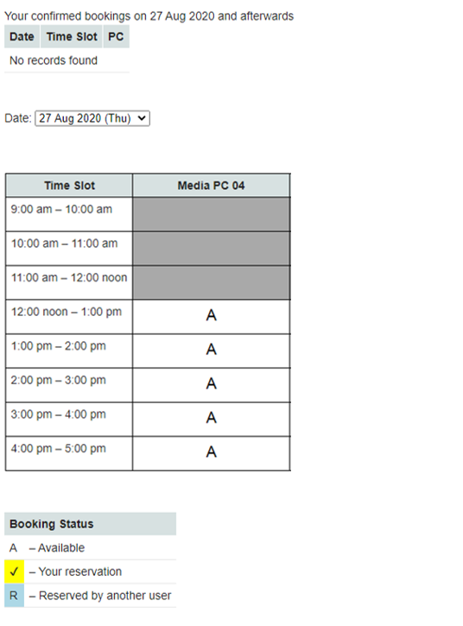

To check booking statuses of other selectable dates, you need to pick an entry from the date dropdown list.

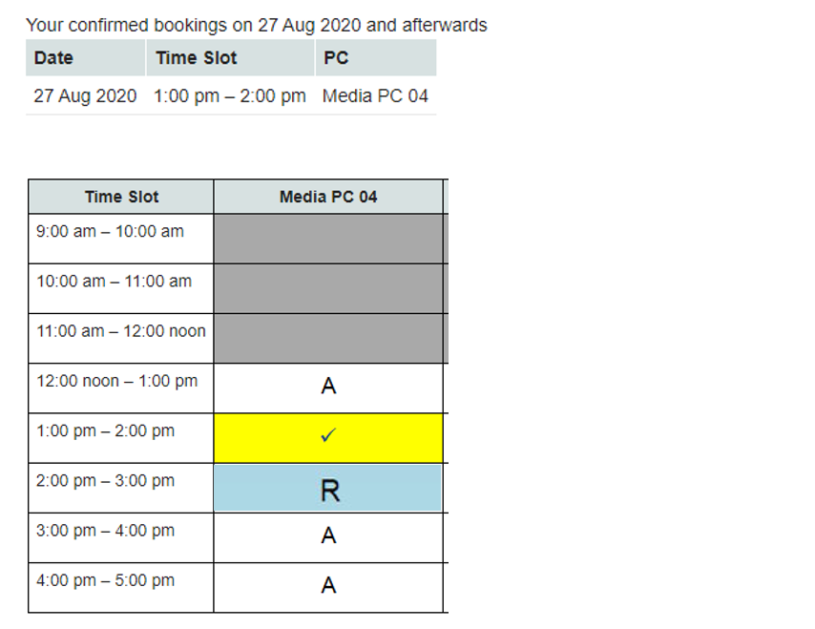
After you have found your desired available timeslot, you can reserve it by clicking on it. The color of the selected timeslot will be changed to yellow with a tick after finished confirmation.

The selected timeslot for Refinitiv Eikon Workstation has been reserved. A confirmation message will appear at the top of the screen.
Please remember to logout after use.

