Application Form for Student Accommodation (Double Rooms) from 14 to 19 July 2019

Participant 1
1. Title:
2. First Name:
3. Last Name:
4. Gender:
5. Institution / Company:
6. Corresponding Address:
7. Contact Number (with Country Code):
8. Email Address:

Participant 2 (please leave this blank if you are applying for single occupancy)
1. Title:
2. First Name:
3. Last Name:
4. Gender:
5. Institution / Company:
6. Corresponding Address:
7. Contact Number (with Country Code):
8. Email Address:

Payment Information
Type of Credit Card: | VISA / Master (delete as appropriate)
Name of Card Holder:
Credit Card Number:
Expiry Date (mm/yyyy): | /
Transaction Amount: | HK$2,200 (HK$440/night for 5 nights)
Signature of Card Holder:

Please note that all payments are non-refundable.

I confirm that I have read and understand the Notes to Participants on pages 2 and 3.

I confirm that both participants (or Participant 1 only for single occupancy) will register at the ISPPCC 2019 on or before 30 April 2019.

Please return a completed form (this page only) to the ISPPCC 2019 Symposium Secretariat at chemisppcc@cityu.edu.hk on or before 23 April 2019.

Notes to Participants
Thank you for choosing the CityU Student Residence for your accommodation. The Student Residence is managed by the Student Residence Office (SRO) and we will strive to provide a safe and comfortable accommodation for you.
Please use a few minutes to read the following IMPORTANT issues for your stay in the Student Residence.
1. Room Provisions
1.1 Rooms for summer letting located in undergraduate halls are mainly double rooms for double occupancy. Single rooms are very limited in number. Every two adjacent rooms form a self-contained unit, sharing a toilet and shower room.
1.2 The provisions of a standard room has desks and typist chairs, wardrobes, overhead bookshelves & IP phone set for free local calls.
1.3 A guest is provided with a set of bedding including a pillow with case, a flat sheet, and a quilt with cover. An extra set of bedding including a pillow case, a flat sheet and a quilt cover will be provided for those who staying for over one week or longer for his/her own replacement and cleaning.
1.4 Free air-conditioning.
2. Common Facilities
2.1 Common Room is located at each floor of the hall. It is equipped with sofa, dining table and chairs, TV, microwave oven for re-heat only, refrigerator, hot and cold drinking water fountain.
2.2 Self-service laundry room is located on the top floor of each hall, opening from 8:00am to 2:00am. The means of payment for laundry machines are operated by Octopus (can be brought from MTR Stations) for Hall 1 to Hall 3, Smartcard for Hall 4 to Hall 9 (can be brought from the SRO 24-hour Security Office HKD50/card).
2.3 Coin-operated telephones for overseas calls are located on G/F in each hall.
3. Cleaning Service
3.1 Basic cleaning of the toilet/shower room will take place once a week. Visitors are encouraged to maintain a hygienic environment and to keep the rooms clean. Cleaning equipment can be found at the Common Room of each floor. A vacuum cleaner can also be borrowed from the security counter on the Ground Floor of each hall.
3.2 Visitors are advised to bring along their own towels and other personal hygiene necessities.
4. Internet Services
4.1 Wi-Fi signal covers only part of the campus and the Student Residence of CityU. For details, please refer to SRO website.
4.2 Visitors can purchase a “prepaid phone card” for local mobile phone service at Homey Kitchen. Details please refer to photos below;

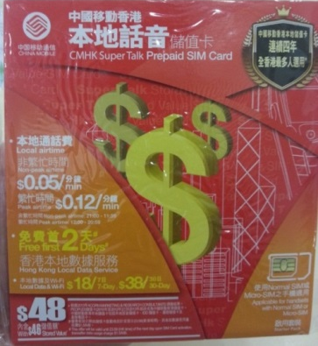 | 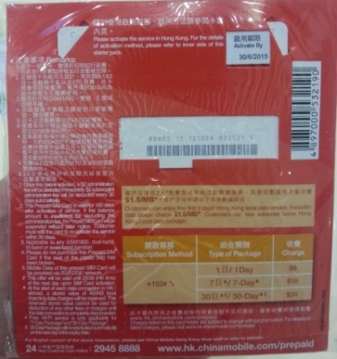

5. Key Cards
5.1 Participants/Visitors must carry valid Key Cards issued by the Student Residence Office during the stay in the Student Residence. The Student Residence Office reserves the right to check the card whenever necessary.
5.2 The Key Card is for access to the Hall and the room assigned. Please take good care of it. A fee will be levied for any replacement of lost/ damaged card (HK$100).
6. Personal Safety and Belongings
Participants/Visitors should undertake the sole responsibility for their own safety and personal belongings during the stay in the Student Residence. The University will not be responsible for any loss of or damage to any articles or things brought into the hall by the visitors.
7. Consideration for Others
Participants/ Visitors should be considerate towards other residents / visitors and must refrain from conduct, which may cause disturbance or inconvenience to other residents / visitors. The period between 11:00 pm and 7:00 am is regarded as quiet hours of the student residence. All visitors are reminded to support a peaceful environment.
8. External Visitors Registration
External visitors are required to register at the G/F security counter at your presence, and shall be required to leave the hall by 12:00 midnight. They are required to respect and observe the Regulations Governing Student Residence.
9. Parking
A drop-off time of 15 minutes is allowed. Visitors are not allowed to park their vehicles in any part of the Hall premises without prior approval of the Student Residence Office.
10. Cleanliness
Visitors should keep all parts of the Hall, including their own bed-study rooms, clean and tidy.
11. Hall Property
Visitors should keep all Hall facilities, furniture and equipment in good order. No furniture or equipment may be removed without prior approval from the Student Residence Office. Visitors must not interfere or tamper with existing fittings or fixtures of the Hall. Visitors will be required to compensate to the University for any loss or damage caused to Hall property.
12. Prohibitions in the Hall
Please be reminded that:
a. No smoking is allowed in both indoor and outdoor areas of the Student Residence.
b. Any illegal and/or dangerous drugs as defined by government ordinance are not permitted to be brought into the Hall by visitors.
c. No gambling of any form is allowed in the hall.
d. No pets are allowed in the hall.
e. For safety reasons, any type of ignition giving rise to a naked flame is prohibited within the hall area.
13. Time for Check-in and Check-out
The times for check-in and check-out are 3 pm and 12 noon respectively. Late check-out is not acceptable. Prior application is required. If approved, 100% of room charge will be levied per room per night.
14. Contact and Opening Hours of Student Residence
Operation time of Student Residence Office: Monday to Friday 9:00 am to 5:30 pm (lunch break from 1:00 pm to 2:00 pm).

Please call Security Office (Student Residence) at (852) 3442-1999 for any emergencies beyond office hours.

CityU Student Residence Office

