Title of Abstract (Times New Roman 12 Bold, Title Case)

First Author (First Name Surname),ª Second Author^{b} and Third Authorª* (Times New Roman 12 plain)

ªFirst Affiliation, Address and Country (Times New Roman 12 Italic)
^{b}Second Affiliation, Address and Country (Times New Roman 12 Italic)

Email: corresponding.author@domain (Times New Roman 12 Plain)

Abstract (Times New Roman 12 plain, justified text, single-line spacing). The whole abstract must fit within one A4 page with all margins set at 1 inch each.

Figures must be integrated in the main text. Please ensure the line width and font size of figures are sufficiently large and clear.

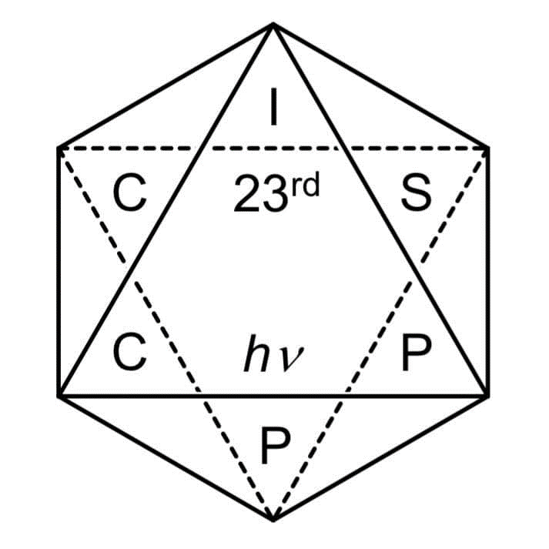
Fig 1. The logo of ISPPCC 2019

References

1. Surname, A. B.; Surname, C. D.; Surname, E. F. Journal Year, Volume, Pages.
2. Surname, H. G.; Surname, I. J. Journal Year, Volume, Pages.

Please prepare the abstract as a Word document (.doc or .docx) with the file name format as “your email address_paper1”.

Example: “chemisppcc@cityu.edu.hk_paper1.doc”.

Please ensure the file is < 3 MB in size.

Submit your abstract: https://www.cityu.edu.hk/chem/isppcc2019/

