AI Mnemonic is a company inside HKSTP. Our founder, Prof. Ling, is an expert in EEG with ~40 patents and our PhDs and postgraduates team members have been working in R&D field for more than 20 years. Previously, we had successfully developed healthcare devices and are now developing an EEG device that can recognize the ongoing activity and measure the EEG signals simultaneously. Traditionally, EEG can identify the user's attention but cannot identify the ongoing activity. Our technology solves the EEG problem so to tell instructors and parents if children pay attention to appropriate content.

With the support of ITC STEM internship, our company is now opening the following positions for undergraduate and / or postgraduate students

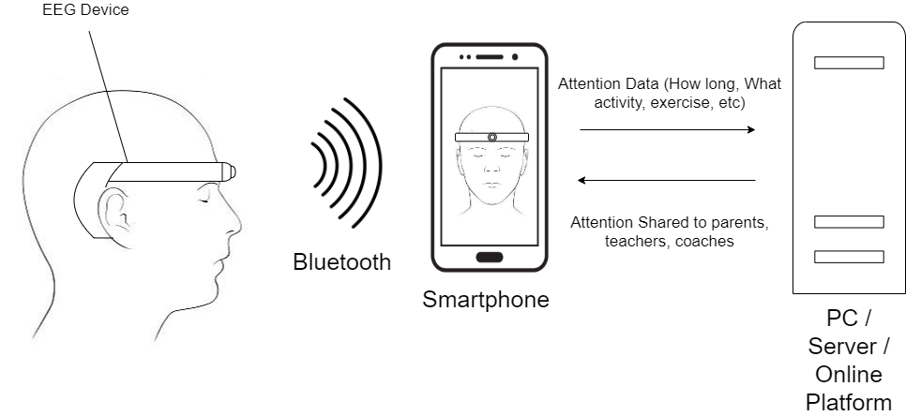

- Job Position: Electronic Engineers (2 positions)
Ref. No. AIM-ITC-EE
Duties:
- To support Sensor related product development
- To assist Schematic Drawing, PCB layout and prototyping
- To assist Product Testing and Test cases development
Requirements:
- With knowledge of analog circuit design
- With knowledge of MCU firmware application programming. Knowledge of Arduino and ESP-32 is preferred
- With Signal processing background of Fourier Transformer
- Preferably students of Electronic Engineering or related disciplines

- Job Position: App/Web Developer (2 positions)
Ref. No. AIM-ITC-AWD
Duties:
- Responsible for Android and web development process, including planning, programming, testing, documenting, deploying, enhancement and maintenance
- Writing well designed, testable and efficient code to connect to Bluetooth devices for collecting physiological signals and images
- Develop codes with AI framework

Requirements:
- With experience in Android Studio, java / Kotlin, iOS, etc
- With experience of PHP, node.js, HTML5, Javascript, etc
- With experience of AI framework such as Tensorflow
- Knowledge of bluetooth specifications
- Preferably students of Science, Engineering or related disciplines
3. Job Position: Image and physiological data analyst (2 positions)
Ref. No. AIM-ITC-IPDA
Duties:
- Label the objects in the images.
- Compute various features in different image objects of different activities
- Train up neural networks to map the features to the different activities
- Familiar with Matlab / Python programming

Requirements:
- Familiar with Matlab / Python programming
- Familiar with signals and systems, digital signal processing, digital image processing, linear algebra and matrix analysis
- Good command in English and Cantonese
- Preferably students of year 3 or above in Science, Engineering or related disciplines

4. Job Position: Product Design Intern (2 positions)
Ref. No. AIM/ITC/IPDA
Duties:
- To support battery operated Product Design and Development from concept stage,
- To assist from hand-sketch concept drawing into 3D prototyping stage,
- To support hand-made prototyping

Requirements:
- With knowledge of consumer product design,
- Essential to have knowledge of prototyping and concept proof,
- Essential to have knowledge of open source product design software
- Preferably students of year 3 or above in Product Design / Mechanical Engineering or related disciplines
5. Job Position: Patent and technical paper writer (2 positions)
Ref. No. AIM-ITC-IPW
Duties:
- Conduct patent research of intellectual property such as novelty search, infringement research to identify patent assets before patent application
- Research and analyze inventions and patent information and to identify prior arts
- Work closely with R&D and Design teams to develop and explore intellectual property opportunities
- Prepare patent specification, drafting and technical paper writing

Requirements:
- Good technical writing skill
- Fluency in Chinese and English (both written and oral)
- Preferably with experience in presenting ideas with drawing and graphics
- Preferably students of year 3 or above in Science, Engineering or related disciplines

6. Job Position: Computer Vision Interns (2 Positions)
Ref. No. AIM-CITYU-CVI
Duties:
- Develop algorithms for object detection and scene analysis
- Develop algorithms to analyze object movement
- Train the AI models and build the platform
Requirements:
- Preferably with experience in computer vision;
- Experience in Python, C++ and Tensorflow;
- Knowledge in deep neural networks;
- Using open sources and cloud services;
- Using open sources and neural network;
- Preferably students of year 3 or above in Science, Engineering or related disciplines

Interested parties pls email your CV to admin@aimnemonic.com

Unit 926, Building 19W,
19 Science Park West Avenue,
Hong Kong Science Park,
Pak Shek Kok, NT
Hong Kong

