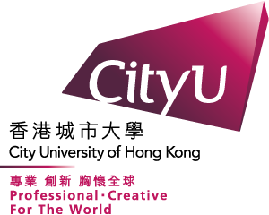 | City University of Hong Kong

Quarterly Report on Course Packs

To : | Collection Development and Management, Library
From : | (Ext: ) | College/School/Dept
Date :

Please find below a summary of the Course Packs compiled and distributed by our department during the following period:
Month: 󠆪󠆪 Jan – Mar 󠆪󠆪 Apr – Jun 󠆪󠆪 Jul – Sep 󠆪󠆪 Oct – Dec Year: ___________
(Please check as appropriate)
Course Code & Title | HKRRLS Ref No | Copyright Charges  (per copy) (HK$) | No. of Copies/Course Users* | Copyright Fee  to HKRRLS (HK$) | PR/PO no./  No PR raised
 | HCPXXXXX
Total
Total (after deduction of the Production Incentive**)

Notes:
- The basic reproduction rate for the materials licensed from HKRRLS is HK$1.05 per page in 2023 and 2024.
- *No. of copies distributed (for printed course pack) or no. of Course Users (for digital course pack).
- ** The production incentive is HK$0.05 per page.
- Please attach the Copyright Clearance Application Form

